GIT STASH:

--------------

Usage: git stash save

This command temporarily stores all the modified tracked files.

Usage: git stash pop

This command restores the most recently stashed files.

Usage: git stash list

This command lists all stashed change sets.

Usage: git stash drop

This command discards the most recently stashed change set.

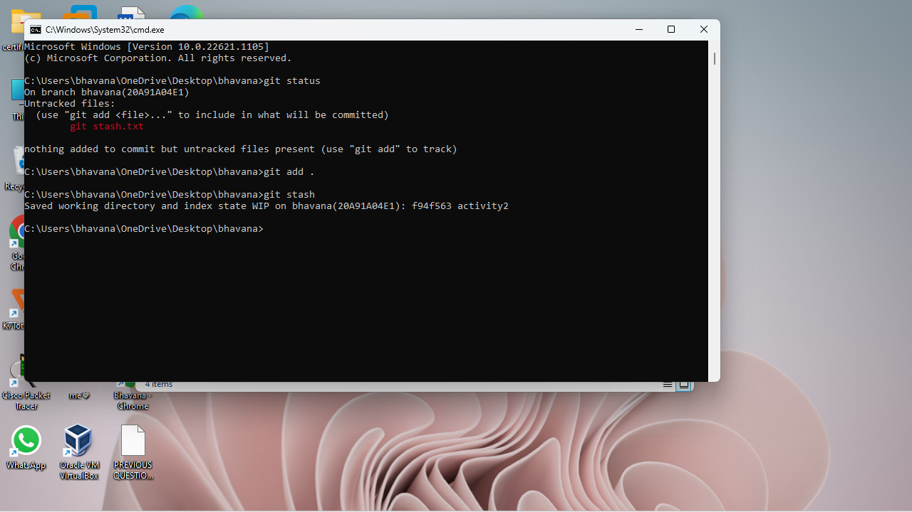

GIT MERGE:

--------------

Usage: git merge [branch name]

This command merges the specified branch’s history into the current branch.

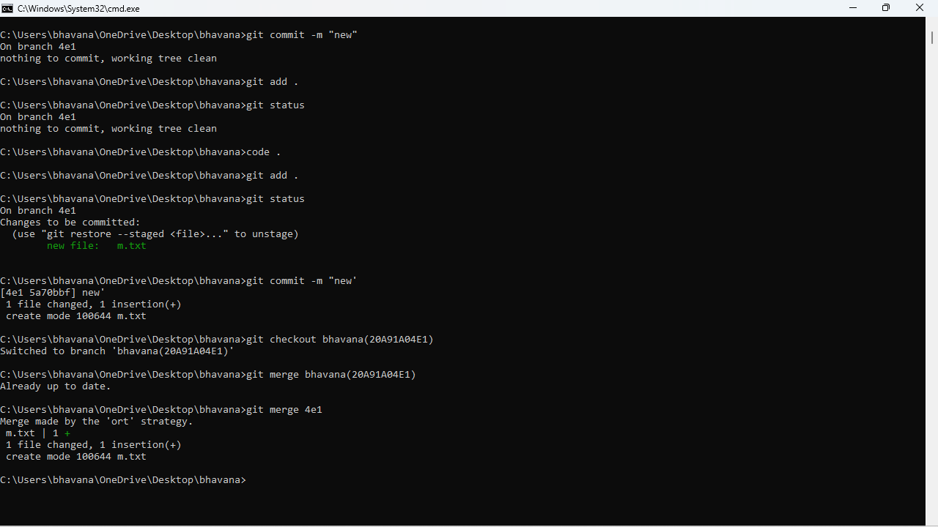

GIT RESET:

-------------

Usage: git reset [file]

This command unstages the file, but it preserves the file contents.

Usage: git reset [commit]

This command undoes all the commits after the specified commit and preserves the changes locally.

Usage: git reset –hard [commit]

This command discards all history and goes back to the specified commit.

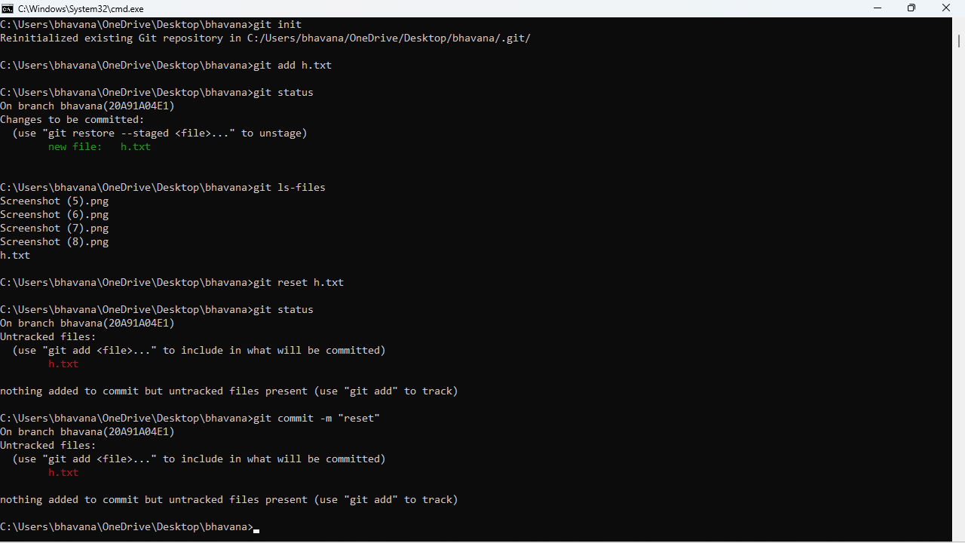

GIT PULL:

-----------

Usage: git pull [Repository Link]

This command fetches and merges changes on the remote server to your working directory.

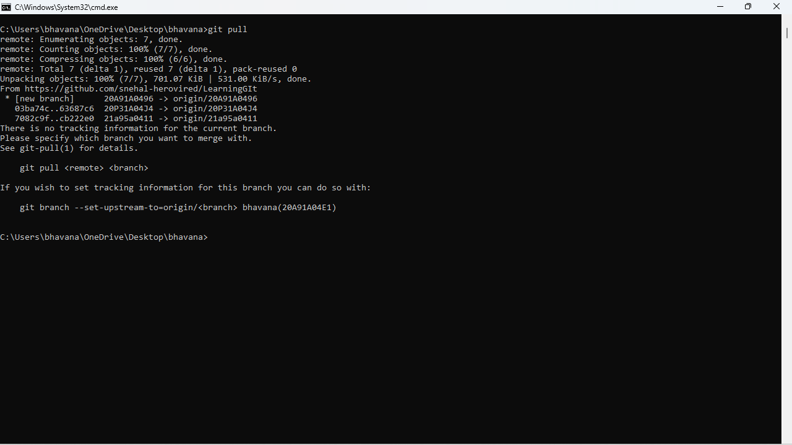

GIT FETCH:

-------------

It is used to download contents from a remote repository .It fetches branches and tags from one or more repositories.

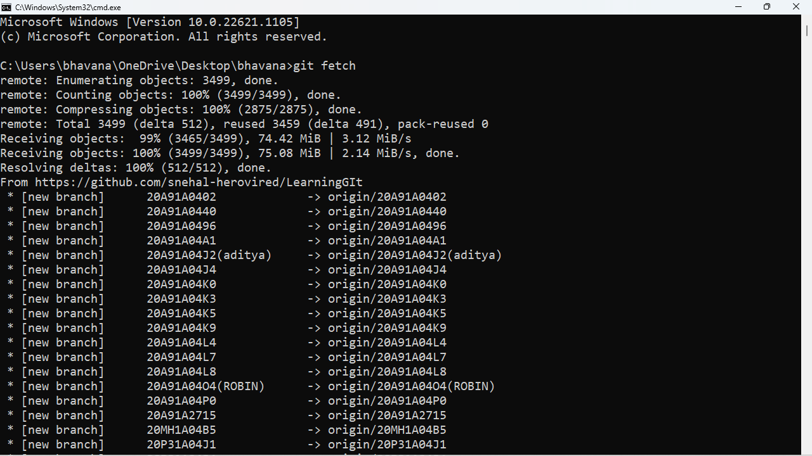

HOW TO FIND HIDDEN FILES IN LINUX?

In this case we use ls -a command in the osboxes terminal then it shows the hidden files.

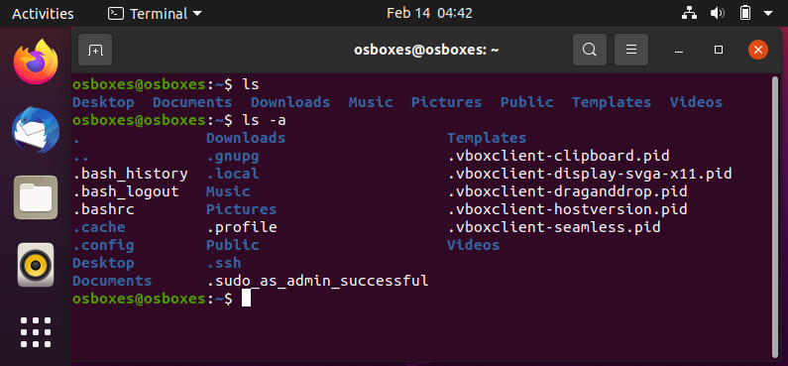

LINUS AWK:

-------------

It is used to print lines by using a specific word present in the given lines.

